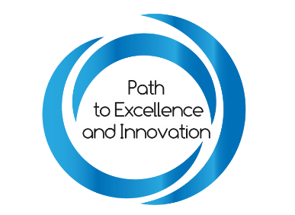
National Institutes of Health (NIH)
Office of Acquisition and Logistics Management (OALM)
Small Business Program Office (SBPO)
STEM Fact Sheet
What is STEM?
STEM can be defined as Science, Technology, Engineering, and Mathematics which is important in today’s world and educational systems as we continue to strive and innovate new ways to help everyone’s understanding of.
How is STEM incorporated within National Institutes of Health (NIH) Small Business Program Office?
The National Institutes of Health (NIH) Small Business Program Office (SBPO) works to broaden the opportunities to Historically Black Colleges and Universities (HBCUs) in the STEM field. Through supporting HBCUs in the grant process and the contract process, NIH’s Small Business Program Office (SBPO) aims to serve as a counsel and advocate to HBCUs in the small business industry and in the STEM field.
PEI 2.0 Cohort: STEM Business and HBCUs
Businesses
Aurora Technical Systems LLC | Dynamic Service Solutions | Kingdomware Technologies, Inc | Symposit LLC
Axis Consultant Group & Associates LLC | Edwards Industries, LLC | Longevity Consulting LLC | Technuf LLC
Axle Informatics | Global Consulting International | Lord and Tucker Management Consultants LLC | VAAS Professionals LLC
Capegemini Government Solutions LLC | Hendall Inc. | MetaMeta LLC | Williams Consulting LLC
Clinical Pharmacy Associates Inc | Immersive Concepts | Oak Ridge Associated Universities
Data Storage Science (DSS) | Intellectual Concepts LLC (IC) | Professional Stewards Services
Delmock Technologies, Inc | Kaizen Approach, Inc | Sage Services Group LLC
Diaspora AI | Key Concepts | SRR International, Inc
HBCUs
Central State University | Fayetteville State University | Morehouse College
Clark Atlanta University | Howard University | Morgan State University
Elizabeth City State University | Jackson State University | University of Virgin Islands

What is the Federal Acquisition Regulations (FAR) of STEM?
DoD encourages contractors to undertake actions, to the maximum extent practicable, that—
- Enhance undergraduate, graduate, and doctoral programs in science, technology, engineering, and mathematics (referred to as ‘‘STEM’’ disciplines);
- Make investments, such as programming and curriculum development, in STEM programs within elementary and secondary schools;
- Encourage employees to volunteer in Title I schools in order to enhance STEM education and programs;
- Make personnel available to advise and assist faculty at such colleges and universities in the performance of STEM research and disciplines critical to the functions of DoD;
- Establish partnerships between the contractor and historically black colleges and universities and minority institutions for the purpose of training students in scientific disciplines;
- Award scholarships and fellowships, and establish cooperative work-education programs in scientific disciplines; or
- Conduct recruitment activities at historically black colleges and universities and other minority-serving institutions or offer internships or apprenticeships.
STEM Resources
- National Institutes of Health (NIH) STEM
- United States Department of Education
- White House Initiative

